**Assignment No 4**

* HLookUp Exercise Question

**Worksheet 1: Sales Data**

**1. Use HLOOKUP to find the sales for Product A in March.**

**Ans:**

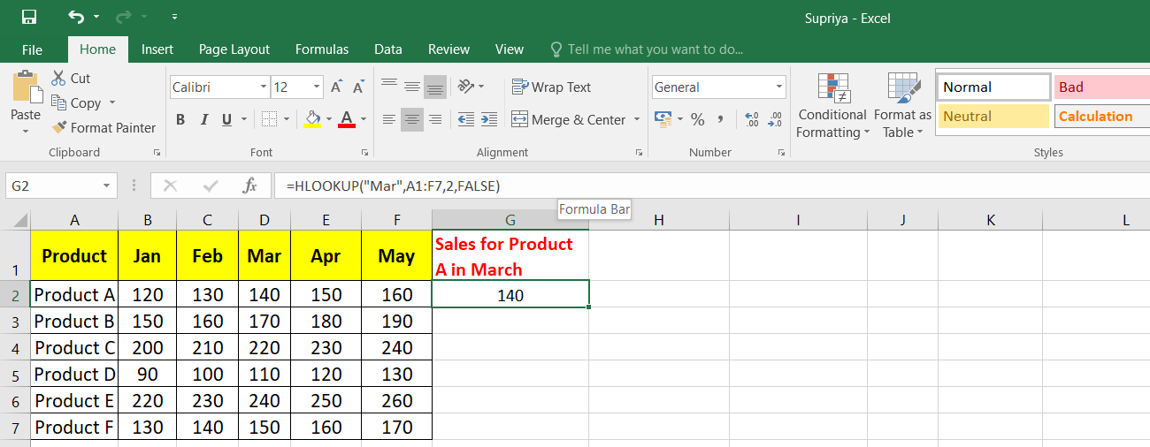

**2. Use HLOOKUP to find the sales for Product D in May.**

**Ans:**

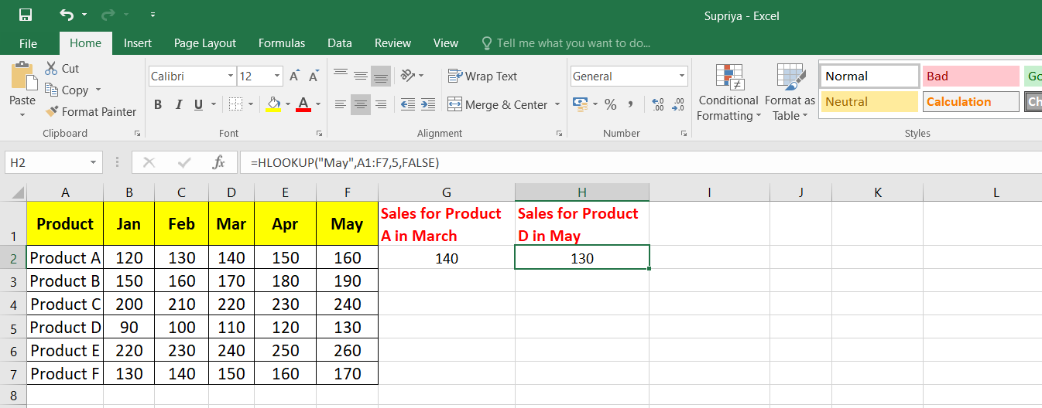

**3. Use HLOOKUP to find the sales for Product C in February.**

**Ans:**

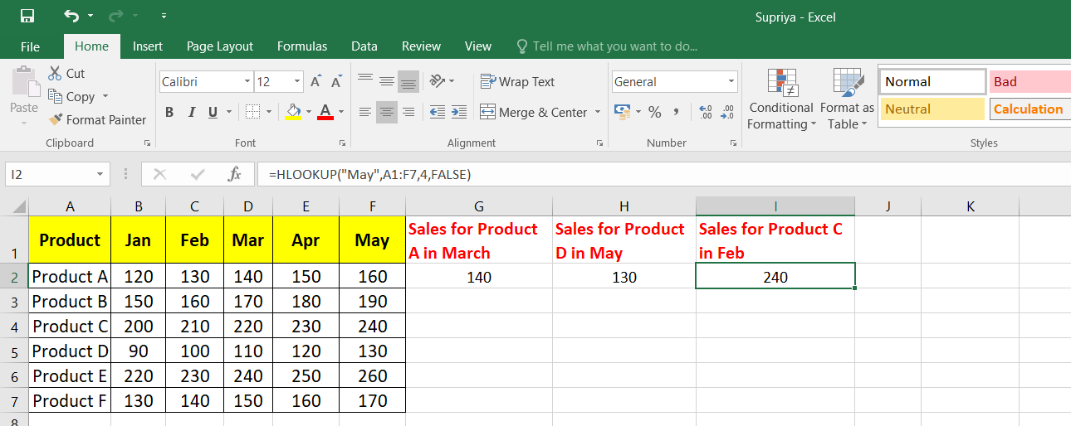

**4. Use HLOOKUP to find the sales for each month for a product, then calculate the total sales for that product.**

**Ans:**

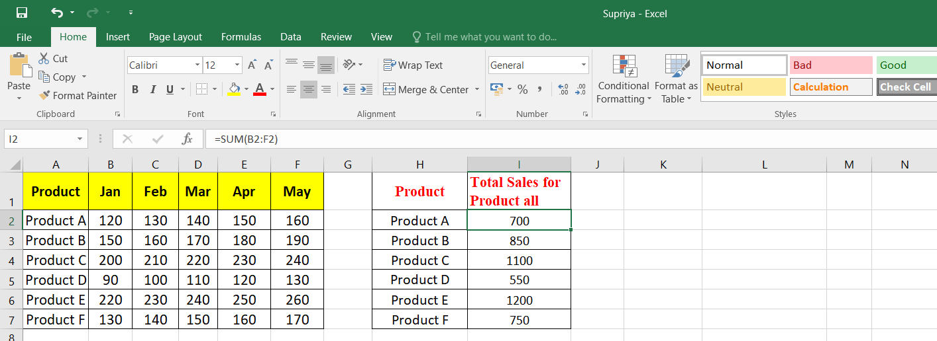

**5. Use HLOOKUP to find the maximum sales value for Product B across all months.**

**Ans:**

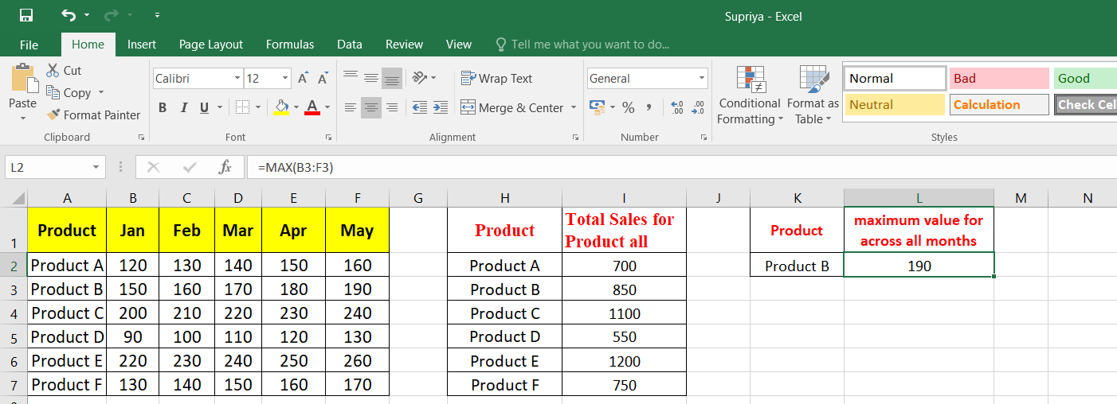

**6. Use HLOOKUP to find the minimum sales value for Product F across all months.**

**Ans:**

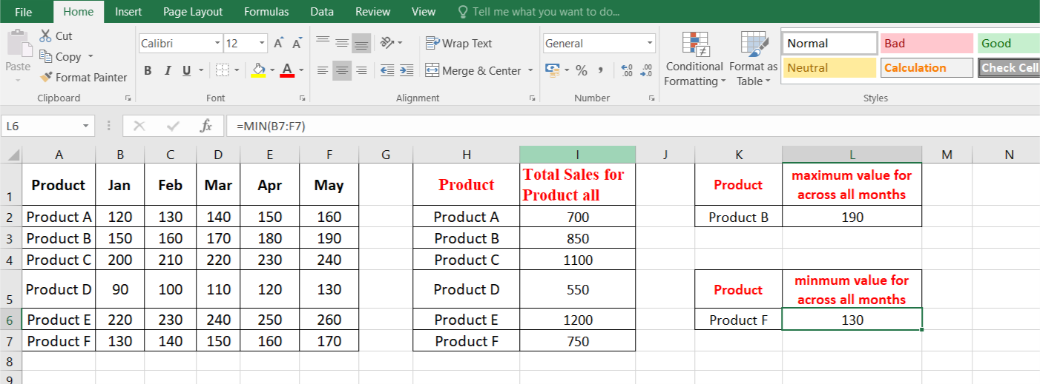

**7. Use HLOOKUP to find the average sales value for Product E across all months**

**Ans:**

